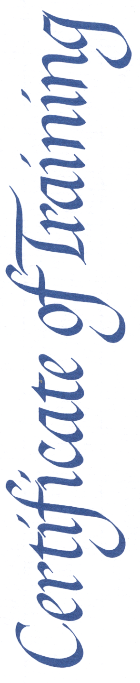

REPLACE THIS TEXT WITH NAME

SOUTH CAROLINA CADET LEADERSHIP COURSE, BASIC CADET

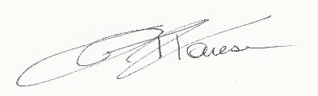
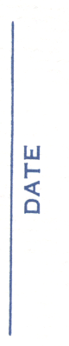
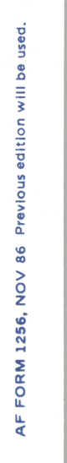

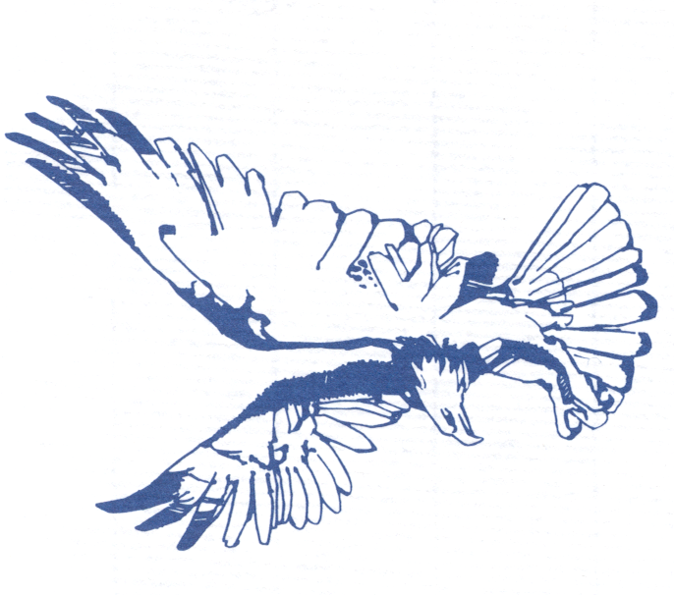
Replace Text with date
MAJ JOHN T. FARESE, USAF (Ret)
Director

