





REPLACE THIS TEXT WITH NAME

***60 CONTACT HOURS, SOUTH CAROLINA CADET LEADERSHIP COURSE***

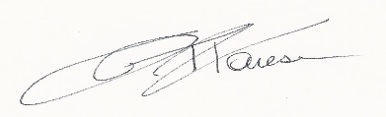

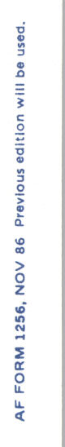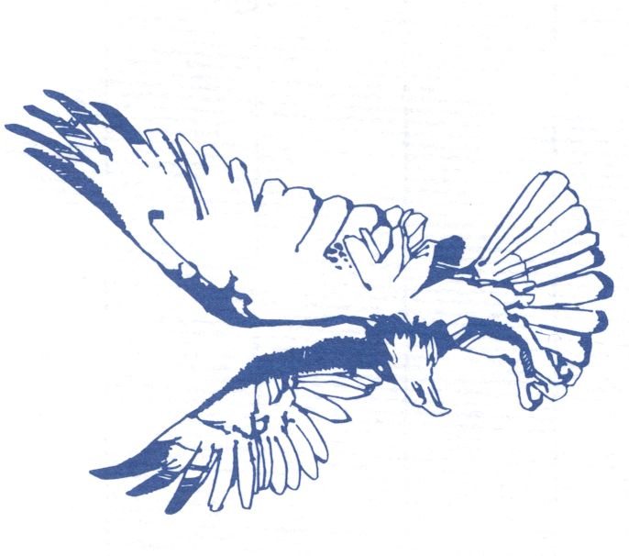

Replace Text with date

MAJ JOHN T. FARESE, USAF (Ret)

Director